

Student & Family Handbook

**2024-2025**

140 View Street, Nanaimo, B.C. V9R 4N6 (250)754-3231

**VISION**

A community paddling together where all members feel a sense of safety, belonging, and opportunity for learning.

**MISSION**

To provide a safe, caring, inclusive, and culturally-responsive learning community built on respect, authenticity, and trust, that empowers our learners to become compassionate, confident, and engaged members of their community. Our diverse learners will be provided with opportunities for spiritual, physical, and mental wellness and growth.

DISTRICT CALENDAR 2024-2025

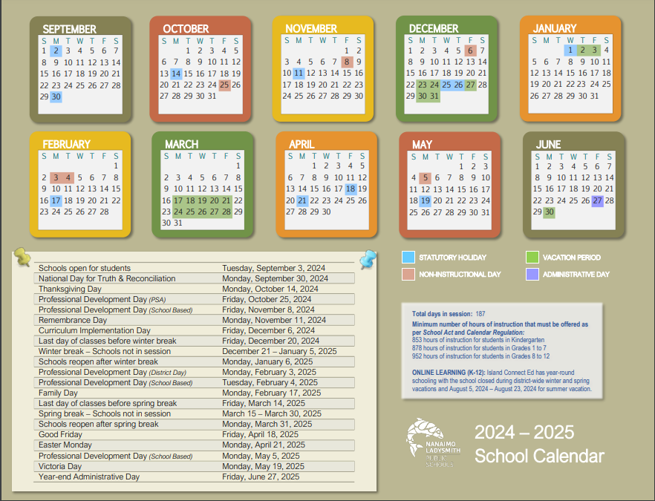

**Bayview Bell Schedule**

Monday – Friday

8:40 Warning Bell

8:45 – 10:15 Instructional Time

10:15 – 10:30 Short Recess

10:30-11:45 Instructional Time

11:45 – 12:20 Long Recess

12:20 – 2:28 Instructional Time

# Attendance

Bayview Elementary places a high level of importance on regular school attendance for ALL students. We track attendance and will contact parents if we are concerned about the number of absences. While occasional absences due to illness are hard to avoid, we highly encourage all students to make their best efforts to attend school on a regular basis! Attendance at school is important for two main reasons:

1. ***Regular attendance ensures a continuity of instruction for all students. Student absence, with parent permission, due to any other reason except illness, places a lesser value on education in the eyes of the child.***
2. ***Student absence, with parent permission, due to any other reason except illness, places a lesser value on education in the eyes of the child.***

***If your child is going to be absent or late, please inform the office at 754-3231. in person or by note prior*** Our attendance records are checked

shortly after the morning bell and phone calls are made to homes to ensure that students are safe***. Please ensure that we always have your current contact information on file at the school.***

***IF you are picking your child up early, please report to the office FIRST to sign them out.***

# Electronics

We understand that personal cell phones are a convenient way to communicate with your children. However, we ask that parents support us in either **keeping cell phones and electronics at home, or encouraging your child to keep them turned off in their bags** during the school day. These **devices are not to be used for capturing photos, videos or audio.** Students may not use social media or communicate with others via their personal electronics while they are at school. **If staff observe student use of personal electronics during the school day, devices will be locked in the office and returned to students or parents at the end of the day.**

Please refer to the Bayview Code of Conduct for a better understanding of expectations around personal electronic devices.

**Supervision of Students Medication & Health**

Supervision is provided from 8:30 a.m. to 2:45pm.

Normally, students are free to move around the various play areas at break times. Bayview’s

R.O.C.K.S. (Respect, Ownership, Cooperation, Kindness & Safety) and using W.I.T.S. (Walk away, Ignore, Talk it out, Seek Help) are our main focus for behaviour and problem-solving outside.

We seek to provide multiple opportunities for students to have intramurals and interest-based activities during recess breaks. These opportunities are a privilege, not a right.

Students must exhibit exceptional behavior during recess activities. After the bell, students should immediately go to the entrance designated by their classroom teacher.

There are a variety of reasons why students may require medication during the school day. Therefore, parents/ caregivers are reminded of the following school district procedures for the administering of any medications at school.

***Parents/caregivers must sign a form, available from the office, before any medication can be administered at school (including antibiotics and Tylenol). Teachers are not required to administer medication, but provisions can be made for appropriately trained staff to do so.***

### Medication can be dangerous! Please do not allow your child to carry or leave medications of any kind in their school bags.

Staff are unable to provide medical care for students. In the event of illness/injury, families or caregivers will be contacted and expected to care for their child.

**School Drills & Emergency Procedures**

**EARTHQUAKE**

Drills are conducted a few times a year.

When shaking stops, the school is evacuated in a quiet and careful fashion, and collect on the back field. In the event of a real earthquake, parents must collect their children in an orderly fashion according to Bayview staff instructions. **Please ensure all contact information is up to date with the office.**

**FIRE**

Drills are conducted several times a year. Any continuous ringing of the fire bell must be taken seriously.

Students evacuate to a designated place on the back field a safe distance from the building.

The deliberate activation of a false alarm is a very serious offense and will result in being dealt with by the appropriate authorities.

**HOLD & SECURE**

Drills are conducted 2 times per year. This occurs when it has been deemed that there is an unsafe situation outside of the school (ie. wild animal). All doors will be secured and blinds closed but students can maintain routines within the building. **No one is allowed to enter or leave the building under any circumstances until the hold and secure is lifted.**

**LOCKDOWN**

Lockdown drills are conducted twice per year. Serious violent incidents at schools are rare events, however; school drills must be practiced to ensure staff and students are prepared to act quickly.

Drills involve all members of the school community to provide the opportunity to practice the skills in the response procedure.

Students are directed to the closest secure area where they remain until the lockdown is over.

**Visitors to the School Smoking & Vaping on Property**



The use of tobacco or marijuana products, including vaping devices, in school buildings and on school property is against the law. ***In March 2007, the B.C. Legislature approved legislation making it illegal to smoke or use tobacco at school.*** Parents are reminded that they must not smoke or use vaping devices in the school building or on school property.

This includes smoking in vehicles while on school grounds.

**All visitors to the school are asked to hand sanitize and sign in at the office when they arrive**. Visitor badges are available and will be given to anyone visiting or working in the school. Only parents with immediate business with their children, or

pre-arranged visits will be given a visitor pass. If you notice a stranger on the playground or in the school without a visitor badge, please notify the office or a supervisor/ teacher on duty.

**Toys & Personal Items**

Students need to be responsible with the toys they are playing with at school. This includes **no trading of toys or cards at school**. We believe that appropriate toys contribute to positive play, but they will only be permitted if they do not cause conflict. Please check with your child’s teacher to see if there are additional classroom expectations for toys at school.

**School staff are not responsible for lost or damaged toys at school; if it is valuable, please leave it at home.**

**Students should not be bringing large amounts of money to school. We are not responsible for lost or stolen money.**

## Outdoor Recess Dress for Success Healthy Eating

Bayview values outdoor play during recess. Unless severe weather is unsafe or creates conditions where it is “impossible to stay dry,” recess will be outside. Students should bring appropriate clothing and outerwear for all weather conditions. When in question, the Principal or designate will check forecasts and consult with staff.

***Help Keep Bayview***

***“Junk-Food Free”***

Healthy food promotes learning and wellness. Healthy snacks including fruit and vegetables help to create minds and bodies that are ready, healthy and keen to learn. **Having junk food such as pop, sugary drinks, energy drinks, iced capps, slurpies, chips or chocolate bars on a regular basis does not promote a healthy lifestyle nor prepare the brain for learning.** The BC curriculum includes the teaching of healthy living habits, including proper sleep, nutrition, and mental health. If students bring these items, they may be directed to wait to consume them until the end of the school day.

Bayview staff feels that students’ clothing should be conducive to learning and be safe to wear. *Student are allowed to wear anything they choose so long as it conforms with the school Code of Conduct requirements for the intended activity and does not promote drugs or alcohol, follows these simple guidelines:*

* Footwear must be worn at all times, and must be considered safe to wear in the case of emergency exits from the building
* Clothing must be appropriate to a school setting ***and be free from any reference to alcohol, drugs, gangs, hate, obscenity, profanity, racism/discrimination, sex, violence and/or “put downs”***

Students who wear inappropriate clothing to school will be asked to change.

Parents/caregivers will be notified.

In the case of an indoor recess, students will be required to

remain in their classrooms, and supervision will be provided.

**Field Trips Bikes & Other Wheels**

### Written permission is required from parents/ guardians

to

**for all field trips. Phone permission will not be granted.**

Bayview affirms the educational value of well planned and supervised field trip learning experiences. Such experiences enrich the curriculum and provide an opportunity for young people to apply their school learning in situations outside the classroom. **Neither curricular nor “whole school, whole class or whole team”**

### extra-curricular field trips shall be denied to a student because of cost.

**Field trips are not “optional” and students are expected to attend.** It is expected that all **students participating in any school sponsored field trip will abide by their school’s code of conduct.** If a student consistently demonstrates challenges with following the school code of conduct, the Principal or designate may offer the parents/caregivers of that child the opportunity to attend the field trip to support their child; alternatively, the Principal or designate may determine that a trip is unfit for a student and provide alternate activities for students at the school. An appropriate program of instruction shall be provided at school for students who do not participate in a field trip.

All “wheels” (bikes, scooters, skateboards, etc) must be walked while on school property between the hours of 8:30 - 3:00 for safety reasons.

All students riding bikes muse adhere to the laws pertaining o helmets:

* The BC helmet law came into effect in September 1996 and applies to all ages.
* The penalty for not wearing a helmet is a fine. For children under 16, the penalty accrues to the parents if aware of the offence.
* If you are injured while riding a bike and are not wearing a helmet, you may be at-fault during an injury

## Reporting of Student Progress

A progress report card is a “sharing” document. It is an opportunity for you to see how your child is progressing and a time for your child to tell you about school. Older students should celebrate their accomplishments and successes with you and identify goals for their next term of the year. Younger students can take the opportunity to tell you about the things they do in school and how they think they are doing. The reports are most meaningful when they are shared and discussed between students and their parents.

#### Assessment of Students’ Progress

Pupil progress is measured through continuous teacher observation of day-to-day performances, and through regular assessment practice (assessment for learning, assessment as learning and assessment of learning). Parents are encouraged to contact the school at any time to discuss the progress of their child.

#### Report Cards

All teachers will do 3 reporting events a year (2 Written Learning Updates and the Summary of Learning). The dates for these are November 27th and March 12th (Written Learning Updates), and June 28th (Summary of Learning).

Each will include an overall comment and descriptive feedback on literacy and numeracy, as well as level of proficiency. All learning standards (subject areas) taught during the reporting period will also be communicated upon and include descriptive feedback. The communications may happen previous to the Written Learning Update – in Spaces or using a work sample and a reporting template. The proficiency indicator will still be indicated in the report card for each subject as well as a note telling parents when the subject area was communicated previously.

The Summary of Learning will include an overall comment and descriptive feedback for every learning standard (subject area), as well as level of proficiency. This will be sent home on the last day of school.

## Snow

**Parking**

**The staff parking lot along Needham St. is NOT to be used as a pass through to drop children off.** Several students walk through this lot and it becomes unsafe when cars move through there.

The community is also reminded that parking (or stopping) is not permitted on the far side of View Street. We have been asked by neighbours to remind parents of this. Please respect our neighbourhood and either pull into a parking space or meet your child at another location.

Remember, Princess Street (behind the school) is a great place to park and meet your child!

If there is severe inclement weather (snow), parents are advised to listen to the local radio stations **(FM – WAVE 102.3/WOLF 106.9/AM – CKEG 1570)** from

6:30 a.m. on to hear an announcement regarding possible school closures. Parents are advised, as well, to listen before noon (schools, depending on circumstances, may be open for the afternoon session).

**SNOWBALLS** – Due to the safety hazards associated with snowballs, ***District Policy states that students should not throw snowballs on the way to, during, or on the way home from school*.**

## Parent Conflicts

Please remember that we work hard to model kind, respectful, and calm relationships for our children. If you have any concerns with another parent, staff member, or student, please arrange an appointment with the Principal or designate to discuss the issue and develop a plan to approach the concern.

Please do not take things into your own hands and harass others, use foul language, or speak about other children or their families with other parents. You never know what someone else is going through, so please act with integrity and compassion when dealing with concerns.

## Meal Program

Our breakfast club is available to any student in need of a nutritious start to their day. The ***breakfast club is open from 8:15 – 8:40 a.m.*** every day. This program is sponsored through donations. You are free to donate funds as well.

**Peanut Aware & Scent Aware School**

**Bayview is a Peanut Aware School**. Please be mindful of sending snacks with peanuts. Help us teach your child to wash their hands after they eat peanut products. We have some students at our school have anaphylactic responses to peanuts, so you may be asked to not bring any peanut products if your child shares a classroom with them.

Thank you for your help

**Bayview is a Scent Free School.** We have some staff members who have severe medical reactions to perfumes and strong scented soaps and detergents. Please be respectful of these medical conditions.

Emergency school lunches and snacks are prepared each day by our district Food for Schools program. These lunches and snacks are intended to be for those who are struggling to provide these meals, and in the case that a parent cannot bring a lunch when it is forgotten. **It is NOT intended to be a choice between what is brought from home and what is offered at school. It is also NOT intended to be provided for students left with the responsibility of making their own lunches but choose not to do so even when they have the food at home**. Please ensure that your child comes to school with enough food for a snack and lunch, if you are able to provide it.

# BAYVIEW PARENH ADVISORY (P.A.C.)

It takes a whole community to raise A Child!

**Check out & join the Facebook page –** [**https://www.facebook.com/bayviewpac**](http://www.facebook.com/bayviewpac)

**Structure of the Meetings**

1. Parents of students in the school are elected to serve on the executive committee that meets monthly from September to June.
2. **All parents** are invited to attend meetings and have input.
3. The Principal attends meetings.

**What is the purpose?**

1. ***To provide a discussion forum for the school’s educational program.***
2. ***To bring ideas/concerns to the attention of the principal and staff members.***
3. ***To meet regarding fundraising and volunteer activities.***

It should be noted that the council **does *not discuss individual or personal issues concerning students/staff****.* This is appropriately conducted with the relevant staff person, student, parents and principal.

**Why a Parent Advisory Council (PAC)?**

* 1. Provides liaison between parents and staff of individual schools in support of facilities, materials and programs that support the education of students.
  2. Provides a structure in which communication between parents and school is facilitated.
  3. Provides a means for the community to become directly involved in support of the students and the school.
  4. Provides a means of keeping parents informed about issues affecting the well-being of their children – education, health and safety.
  5. Provides a means of publicizing school events, and involving parents in the larger educational community, of school board, District Parent Advisory Council (D.P.A.C), local and provincial educational issues.
  6. Provides a means for parents to have immediate input into Bayview’s efforts.

The PAC works in the best interest of your child and needs your support on committees and at one meeting per month. Many hands make light work! Become a part of our dynamic learning community for the benefit of all the children at Bayview

## Lice

***LICE: Not a health risk, not a safety risk - just a plain nuisance*** Each year, all year, every school in B.C. is bothered by this pesky nuisance. If your son or daughter, or one of their classmates gets lice you will receive a letter from the school. If you need assistance to rid your son, daughter or family of this unwanted guest, please contact the school—–we may be able to assist you. **(250-754-3231)**

**Head Lice Facts From V.I.H.A.:**

* Lice are tiny insects about the size of a sesame seed.
* Anyone with hair can get head lice.
* Lice do not have wings and cannot fly or jump.
* Lice move quickly in dry hair, and this makes them hard to see.
* Lice can only stay live on the head and will only lay eggs on the head.
* Having head lice does not always make the scalp itchy.
* Lice move to other heads when heads touch and by sharing brushes and combs.
* Lice are common where children play or work closely together.
* Adult lice live about 20 days and lay about 10 eggs each day.
* Lice eggs are called nits and are glued to hair near the scalp.
* It takes about 7 to 10 days for the lice eggs to hatch.
* Once a lice egg has hatched the empty eggshell stays stuck to the hair.
* If you find an eggshell more than half an inch away from the scalp it is most likely empty.
* The eggshells are white and look like dandruff but cannot be brushed or blown away.

# Community Programs & Agencies

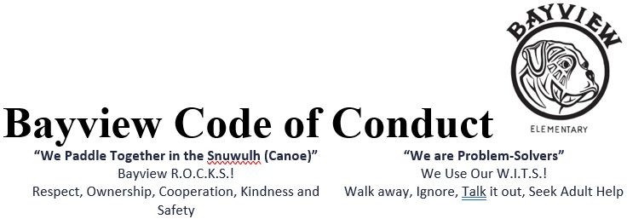

**Purpose**

At Bayview Elementary School we are dedicated to developing a safe, caring, inclusive and welcoming environment that promotes the rights and responsibilities of all who learn and work together. This environment will allow each child to reach his or her potential, experience growth, be a contributing citizen and a lifelong learner.

*This code of conduct will serve****…***

* To establish and maintain a safe, caring, inclusive and welcoming environment.
* To clarify and publish expectations for student behavior at school, going to and from school, and while attending any school function or activity.
* To establish and maintain appropriate balances among individual and collective rights, freedoms, and responsibilities.
* To promote the values expressed in the **BC Human Rights Code** respecting the rights of all individuals.
  + To outline ways in which Bayview staff is educative, preventative and restorative in practice and response.

**Reference to the BC Human Rights Code**

The ***BC Human Rights Code*** states that three of its purposes are to:

“(a) foster a society in British Columbia in which there are no impediments to full and free participation in economic social political and cultural life of British Columbia

(b) promote a climate of understanding and mutual respect where all are equal in dignity and rights.

(e) to provide a **means of redress** for those persons who are discriminated against contrary to this Code.”

It further states 8 1 (b) a person must not “discriminate against a person or class of persons regarding any accommodation, service or facility customarily available to the public because of the race, colour, ancestry, place of origin, religion, marital status, family status, physical or mental disability, sex, sexual orientation, gender identity or expression, or age of that person or class of persons.”

The ***Safe Caring and Orderly Schools: A Guide*** states, schools should be places where students are free from harm, where clear expectations of acceptable behaviour are held and met, and where all members feel they belong.

|  |  |
| --- | --- |
| NLPS Inclusion Policy states that all members of our school community “have the right to expect that policies, procedures, programs and communications are inclusive and respectful” | Administrative Procedure that support the school Code of Conduct include:   * AP 312 - Harassment, Intimidation, Bullying and Discrimination * AP 344 - Code of Conduct * AP 345 – Student Suspension * AP 347 - Sexual Orientation and Gender Identity * AP 250 - Honouring Diversity and Challenging Racism |

**Conduct Expectations**

Bayview’s Code of Conduct expects that students will demonstrate socially responsible behaviours that reflect respect and safety at school and while attending a school function at any location.

**Acceptable conduct** refers to socially responsible behaviours that help to make the school a safe, caring and inclusive environment including:

* Contributing positively to the school community
* Solving problems in peaceful ways
* Valuing diversity
* Defending human rights
* Respectful interactions with students, staff and community members
* Speaking up and reporting incidents that demean others or threaten the personal or emotional safety of individuals or groups
* Respect the law as it applies to yourself and others

Note: Additional specific expectations for acceptable conduct are outlined in the Bayview P.B.I.S. positive behavior matrix. The behaviours are taught, practiced and modeled by all staff and students.

**Unacceptable conduct** refers to behaviour that interferes with the safe and orderly environment of the school, either person-to-person basis or through social media, including, but not limited to:

* Engaging in incidents of harassment, intimidation, bullying or discrimination
* Interfering with the learning or orderly environment of the school or function
* Verbal threats of physical and/or emotional harm, swarming
* Illegal acts such as: theft or damage to property, possession or distribution of an illegal or restricted substance, possession, use of a weapon, or physical violence.

**AP 344 - Code of Conduct states**: “Students with identifiable special needs might be unable to comply with a code of conduct due to having a disability of an intellectual, physical, sensory, emotional or behavioural nature. Such students may require special consideration in the selection of appropriate forms of intervention to ensure that they are not subject to disciplinary or intervention measures as a direct or indirect consequence of having a special need.”

**Personal Digital Device Restrictions**

Research suggests that restricting the use of personal digital devices at school leads to improved student wellness and academic focus.  The use of personal digital devices during the school day, inclusive of outdoor recess breaks, is limited to instructional purposes and digital literacy in a way that is appropriate to the students’ age and developmental stage, under the direction of the classroom teacher.  Consideration will be given to:

* accessibility and accommodation needs;
* medical and health needs;
* equity to support learning environments.

The school team will work collaboratively with families to ensure students have the support needed to manage their device usage in a healthy and safe manner.

**Rising Expectations**

Bayview Elementary staff use the *BC Performance Standards for Social Responsibility* to assess and teach students appropriate social behaviour. There is an outline of progression of expectations held for students as they become older, more mature and move through successive grades. The expectations are educative, preventative and allow for many opportunities to teach the same social skill in a variety of ways.

**Consequences**

NLPS Inclusion Policy states:

“The Board expects that all students, staff, and members of our school communities will adhere to a code of conduct that is educative, preventative and restorative in practice and response”

1. **Restorative Practices**

* focus on creating conditions for students to learn self-discipline, fix mistakes and return to the group/class/school strengthened.
* address the needs of those who have been harmed
* encourage the students, as often as possible, to participate in the development of meaningful, interventions through discussion or mediation to replace, repair or make “good” what has been taken, damaged, destroyed and/or defaced.
* responses to the harm are meaningful in addressing the needs of all involved
* help students reclaim their self-esteem through self-evaluation, personal effort and restitution
* provide opportunities to model leadership
* emphasize the importance of positive relationships in building community and,
* speak to the obligation we all have to each other to move towards wholeness, restoration and belongingness.

Meaningful consequences may include:

* a ‘do over’ opportunity
* face to face meetings to address the harm done
* group or classroom circles to restore equity, balance and respect
* an act of service to make a positive contribution to the class, school or community
* school/community support to learn and practice problem solving or conflict resolution strategies
* reflective/think process that includes the opportunity to create a plan to restore the harm done

1. **Student Suspension**

Discipline measures used with students should be viewed within the context of helping students achieve intellectual and social development. The purpose of suspension, or any other discipline strategy, should be to meet these goals and to develop self-reliant adults.

Suspension is one strategy in a more complex problem-solving process designed to support a student in changing inappropriate behaviour. Used judiciously, suspension can have positive effects, including:

* ensuring safety for everyone in the school community
* assigning clear consequences for a range of serious breaches of code of conduct
* providing the time for planning of support for behaviour change
* promoting collaboration among family, school, and other community services to solve problems

Note: To be equitable, consequences may vary from student to student where the misconduct appears to be similar. Intervention must be appropriate to the student’s age, maturity, needs, exceptionalities, extenuating circumstances and the nature of previous intervention taking in consideration of the needs of the school.

Refer to **AP 344 Student Suspension**

**Notification**

School staff may advise other parties or agencies of serious breaches of the code of conduct depending on the severity and/or frequency of misconducts and the impact on others and/or the school community. Illegal acts will be reported to the RCMP and/or District Administration to develop a safety plan that will include the components of education, prevention and restorative action.

**Retaliation**

No student, school employee, parent or volunteer may engage in reprisal or retaliation against a victim, witness, or other person who brings forward information about an act of harassment, intimidation, bullying, prejudice or discrimination. Reprisal or retaliation is prohibited and will result, where appropriate, in discipline and/or in the filing of a complaint with other appropriate authorities.

**Appeal Process**

The Board of Education recognizes and respects the fact that students and /or parents or guardians may sometimes disagree with decisions made by employees. The School Act of British Columbia gives parents or guardians and students (with parental consent) the right to express concerns or appeal certain decisions. This right of appeal applies to decisions that significantly affect the health, education or welfare of students. Information regarding the Board’s appeal procedure and a copy of the formal appeal bylaw can be accessed at sd68.bc.ca / Board Policies / 1000 Board Governance / 4.0 Bylaws. Prior to an appeal it is expected that school administration, students and parents or guardians will work to try to resolve concerns at the school level.